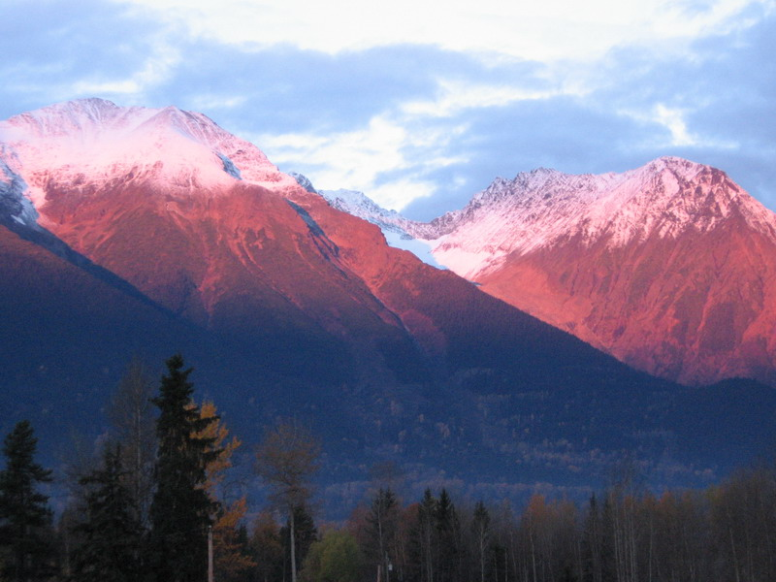
Stand Development Monitoring
Bulkley TSA Summary

THIS SUMMARY IS BASED ON DATA FROM LESS THAN 30 SURVEYED POLYGONS. THE RESULTS PRESENTED ARE CONSIDERED PRELIMINARY.

This summary is from polygons surveyed in the Bulkley TSA in and 2011. This summary is an example of the variety and depth of information that can be extracted from SDM data.

Currently, SDM field survey data is entered into an EXCEL spreadsheet template. This template provides an individual polygon data summary for immediate use. These spreadsheets are then loaded into the SDM ACCESS database. The database can be queried to produce an aggregated data summary like this one that includes data from multiple polygons within a TSA. The queries can be adjusted to extract data in various combinations depending on the user’s needs.

This summary is not an analysis; it provides limited interpretation of the data. Reports examining specific questions regarding productivity or that seek to explain trends and other behaviours can be constructed based on this data along with the use of other supporting tools or evidence.

Provincial and regional Forest Health and Silviculture staff can be asked to help with the interpretation of the information presented in the summaries and in the creation of more detailed reports.

Your input as comments and suggestions are needed to further develop these summaries. Please contact Harry.Kope@gov.bc.ca and provide your suggestions for improvement.

.
STAND DEVELOPMENT MONITORING - Bulkley TSA Summary
Purpose and Audience – Data summaries can help statutory decision makers and operational foresters make informed decisions on stand development, TSR data package inputs, FSP renewals, and FFT activity priorities. They provide information on the growth and health of managed stands.
The Forest and Range Evaluation Program in conjunction with the provincial forest health program have designed an evaluation protocol (Stand Development Monitoring - SDM) that assesses the condition of post-free-growing managed stands by measuring stand attributes and the impact of biotic and abiotic damaging factors on stand health to determine whether these free-growing stands are meeting productivity expectations.
NOTE – This report provides summary information obtained from the surveyed polygons. Inferences from these summaries should be made cautiously.
This summary includes data on: Sample Summary Forest Health Stand Density Species Composition Site Index
SAMPLE SUMMARY
Polygon and polygon population attributes, and numbers and percentages of sampled live trees.
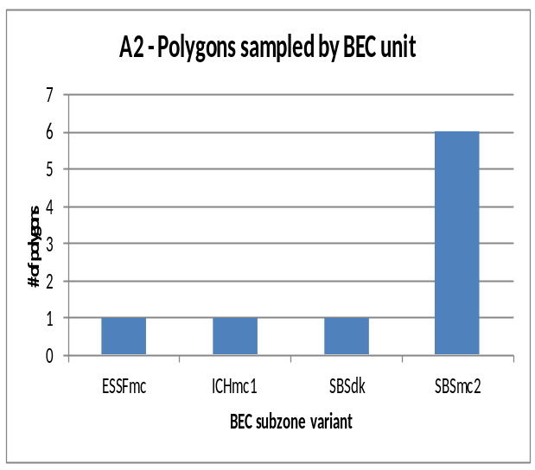
A1 – number of polygons sampled
Survey year: | 2011
DSS | 9

A3 - sampled polygon attributes
Attribute | nª | Mean | SD^{b} | Range
Polygon net area (ha) | 9 | 22.0 | 11.6 | 10 to 43
Stand Age (yrs) | 4 | 19.3 | 5.3 | 16 to 27
Harvest to Declaration (yrs) | 4 | 13.3 | 3.4 | 10 to 18
Planting to Declaration (yrs) | 4 | 11.8 | 4.1 | 7 to 17
Declaration to SDM (yrs) | 4 | 6.0 | 2.9 | 3 to 9
ª. Differing ‘n’ values indicate missing information for some polygons.
^{b}. SD - Standard Deviation

A4 - sample population coverage
TSA  polygon population  (n) | Total polygon population  area (ha) | Number Polygons  ≥5 ha  (n) | Population polygon area  ≥5 ha  (ha) | Number of polygons sampled  (n) | Sampling intensity by number of polygons | Area  sampled  (≥5 ha)  (ha) | Sampling intensity by area
502 | 9950 | 391 | 9651 | 9 | 23.% | 197.8 | 2.0%

A5 - number and percentage of sampled total live trees
Tree species: | Ac | Acb | Act | At | Bl | Cwi | Ep | Hm | Hwi | Pli | Sx | Total
Number | 18 | 1 | 20 | 66 | 268 | 1 | 2 | 10 | 81 | 454 | 300 | 1221
Percent | 1 | 0 | 2 | 5 | 22 | 0 | 0 | 1 | 7 | 37 | 25 | 100
X1 - Tree Species Abbreviations
Ac –Poplar Ep – Paper Birch
Acb – Balsam Poplar Hm – Mountain Hemlock
Act – Black cottonwood Hwi – Western Hemlock (Interior)
At – Aspen Pli – Lodgepole Pine (Interior)
Cwi – Western red Cedar (Interior) Sx - Spruce hybrid
Bl – Subalpine Fir

FOREST HEALTH
Forest Health is assessed using the SDM damage criteria for mid-rotation stands (see Appendix 1). The damage criteria establish forest health threshold tolerances identifying unacceptable and damaged trees, which are labelled pest affected trees. In the Bulkley TSA the pathogen most recorded was Western Gall Rust (DSG); the insect damage was Warren’s root collar weevil(IWW); the animal damage was Moose (AM); the abiotic damage was Snow press (NY).
B1 – average stems per ha by forest health status
X2 – tree layers
Layer 1 >12.5 cm dbh
Layer 2 7.5 to 12.5 cm dbh
Layer 3 >1.3 m in height to 7.49 cm dbh
District | Live Acceptable Trees (sph) | Live Unacceptable Trees (sph) | Dead Unacceptable Trees (sph) | Total Stemsª (sph)
DSS | 2276 | 438 | 82 | 2796
ª For forest health purposes total stems equals all live trees plus all dead trees.
X3 – forest health abbreviations
DSG – Western gall rust AM – Moose VT – Tree competition
DFS –Dothistroma needle blight AP - Porcupine UBT – Broken top
DSC – Comandra blister rust AS – Squirrel UF - Fork
IWW – Warren’s root collar weevil NY – Snow press NWS - Windthrow
IWS – White pine weevil TL - Logging VP – Vegetation press
U – Unknown
B2 - forest health factors detected
(Brackets are the number of plots with a specific forest health factor. Plots =90)
Pathogen DSG (24) DSF (3) DSC (3)
Insect IWW (25) IWS (2)
Animal AM (12) AP (4) AS (1)
Abiotic NY (36) TL (8) VT (5) UBT (4) UF (1) NWS (1) VP (1)
Unknown U (2)

B3 - incidence of forest health factor by bec
BEC | Tree Layer | Total Stems | Acceptable Trees |  | Unacceptable Trees |  |  |  |  |  |  | Percent incidence^{c} of Forest Health Factor^{d} for each tree layer
 |  |  |  |  | Live |  | Dead
BEC | Tree Layer | Total Stems | n | (%^{b}) | n | (%^{b}) | n | (%^{b}) | DSG |  | DFS |  | DSC | IWW | IWS | AM | AP | NY | TL | UBT | VT | Other | U
ESSFmc | 1 | 5 | 5 |  | 0 |  | 0 |  | - |  | - |  | - | - | - | - | - | - | - | - | - | - | -
 | 2 | 26 | 24 |  | 1 |  | 1 |  | - |  | - |  | - | - | - | 3.8 | - | 3.8 | - | - | - | - | -
 | 3 | 172 | 159 |  | 13 |  | 0 |  | - |  | - |  | - | - | - | - | - | 7.6 | - | - | - | - | -
 |  | 203 | 188 | (92.6) | 14 | (6.9) | 1 | (0.5) | 0.0 |  | 0.0 |  | 0.0 | 0.0 | 0.0 | 0.5 | 0.0 | 6.9 | 0.0 | 0.0 | 0.0 | 0.0 | 0.0
IChmc1 | 1 | 13 | 12 |  | 1 |  | 0 |  | - |  | - |  | - | - | - | - | - | - | - | - | - | 7.7 | -
 | 2 | 38 | 36 |  | 2 |  | 0 |  | - |  | - |  | - | - | 5.3 | - | - | - | - | - | - | - | -
 | 3 | 102 | 101 |  | 1 |  | 0 |  | - |  | - |  | - | - | - | - | - | - | - | - | - | 1.0 | -
 |  | 153 | 149 | (97.4) | 4 | (2.6) | 0 | (0.0) | 0.0 |  | 0.0 |  | 0.0 | 0.0 | 1.3 | 0.0 | 0.0 | 0.0 | 0.0 | 0.0 | 0.0 | 1.3 | 0.0
SBSdk | 1 | 17 | 15 |  | 2 |  | 0 |  | - |  | - |  | - | - | - | - | - | - | - | - | - | 11.8 | -
 | 2 | 50 | 30 |  | 20 |  | 0 |  | 4.4 |  | 4.4 |  | - | - | - | 24.0 | - | - | - | - | - | 8.0 | -
 | 3 | 58 | 36 |  | 22 |  | 0 |  | - |  | 3.4 |  | - | - | - | 31.0 | - | - | - | - | 1.7 | 1.7 | -
 |  | 125 | 81 | (64.8) | 44 | (35.2) | 0 | (0.0) | 1.6 |  | 3.2 |  | 0.0 | 0.0 | 0.0 | 24.0 | 0.0 | 0.0 | 0.0 | 0.0 | 0.8 | 5.6 | 0.0
SBSmc2 | 1 | 118 | 89 |  | 27 |  | 2 |  | 5.9 |  | - |  | 0.8 | 0.8 | - | - | 5.9 | 6.8 | - | - | - | 3.4 | -
 | 2 | 142 | 104 |  | 34 |  | 4 |  | 8.5 |  | - |  | - | 0.7 | - | 0.7 | - | 10.0 | 1.4 | 0.7 | - | 4.2 | -
 | 3 | 516 | 413 |  | 74 |  | 29 |  | 2.1 |  | - |  | 0.8 | 2.5 | - | 1.7 | - | 4.7 | 5.2 | 0.6 | 1.6 | 0.8 | -
 |  | 776 | 606 | (78.1) | 135 | (17.4) | 35 | (4.5) | 3.9 |  | 0.0 |  | 0.6 | 1.9 | 0.0 | 1.3 | 0.9 | 6.1 | 3.7 | 0.5 | 1.0 | 1.8 | 0.0
a. Averages on a per ha basis b. For forest health purposes total stems equals total live plus total dead c. Percent of the total stems d. Only the top 13 forest health factors are included in the table
B4 - incidence of forest health factor by tree species
Tree Species | Tree Layer | Total Stems | Acceptable Trees |  |  | Unacceptable Trees |  |  |  |  |  |  |  | Percent incidence^{c} of Forest Health Factor^{d} for each tree layer
 |  |  |  |  |  | Live |  |  | Dead
Tree Species | Tree Layer | Total Stems | n | (%^{b}) | n |  | (%^{b}) | n |  | (%^{b}) | DSG |  | DFS |  | DSC | IWW | IWS | AM | AP | NY | TL | UBT | VT | Other | U
At | 1 | 4 | 3 |  | 1 |  |  | 0 |  |  | - |  | - |  | - | - | - | - | - | - | - | - | - | 25.0 | -
 | 2 | 31 | 15 |  | 15 |  |  | 1 |  |  | - |  | - |  | - | - | - | 42.5 | - | - | - | - | - | 6.5 | -
 | 3 | 71 | 54 |  | 17 |  |  | 0 |  |  | - |  | - |  | - | - | - | 22.5 | - | - | - | - | - | 1.4 | -
 |  | 105 | 71 | (67.6) | 33 |  | (31.4) | 1 |  | (1.0) | 0.0 |  | 0.0 |  | 0.0 | 0.0 | 0.0 | 28.6 | 0.0 | 0.0 | 0.0 | 0.0 | 0.0 | 3.8 | 0.0
Bl | 1 | 4 | 4 |  | 0 |  |  | 0 |  |  | - |  | - |  | - | - | - | - | - | - | - | - | - | - | -
 | 2 | 14 | 12 |  | 1 |  |  | 1 |  |  | - |  | - |  | - | - | - | - | - | - | 14.3 | - | - | - | -
 | 3 | 265 | 230 |  | 21 |  |  | 14 |  |  | - |  | - |  | - | - | - | 1.5 | - | 0.8 | 9.8 | - | 0.8 | 0.4 | -
 |  | 283 | 246 | (86.9) | 22 |  | (7.8) | 15 |  | (5.3) | 0.0 |  | 0.0 |  | 0.0 | 0.0 | 0.0 | 1.4 | 0.0 | 0.7 | 9.9 | 0.0 | 0.7 | 0.4 | 0.0
Cw | 2 | 1 | 1 |  | 0 |  |  | 0 |  |  | - |  | - |  | - | - | - | - | - | - | - | - | - | - | -
 |  | 1 | 1 | (100.0) | 0 |  | (0.0) | 0 |  | (0.0) | 0.0 |  | 0.0 |  | 0.0 | 0.0 | 0.0 | 0.0 | 0.0 | 0.0 | 0.0 | 0.0 | 0.0 | 0.0 | 0.0
Ep | 1 | 1 | 1 |  | 0 |  |  | 0 |  |  | - |  | - |  | - | - | - | - | - | - | - | - | - | - | -
 | 3 | 1 | 1 |  | 0 |  |  | 0 |  |  | - |  | - |  | - | - | - | - | - | - | - | - | - | - | -
 |  | 2 | 2 | (100.0) | 0 |  | (0.0) | 0 |  | (0.0) | 0.0 |  | 0.0 |  | 0.0 | 0.0 | 0.0 | 0.0 | 0.0 | 0.0 | 0.0 | 0.0 | 0.0 | 0.0 | 0.0
Hm | 2 | 1 | 1 |  | 0 |  |  | 0 |  |  | - |  | - |  | - | - | - | - | - | - | - | - | - | - | -
 | 3 | 9 | 6 |  | 3 |  |  | 0 |  |  | - |  | - |  | - | - | - | - | - | 22.2 | 11.1 | - | - | - | -
 |  | 10 | 7 | (70.0) | 3 |  | (30.0) | 0 |  | (0.0) | 0.0 |  | 0.0 |  | 0.0 | 0.0 | 0.0 | 0.0 | 0.0 | 20.0 | 10.0 | 0.0 | 0.0 | 0.0 | 0.0
Hw | 1 | 2 | 2 |  | 0 |  |  | 0 |  |  | - |  | - |  | - | - | - | - | - | - | - | - | - | - | -
 | 2 | 3 | 3 |  | 0 |  |  | 0 |  |  | - |  | - |  | - | - | - | - | - | - | - | - | - | - | -
 | 3 | 76 | 75 |  | 1 |  |  | 0 |  |  | - |  | - |  | - | - | - | - | - | - | - | - | - | 1.3 | -
 |  | 81 | 80 | (98.8) | 1 |  | (1.2) | 0 |  | (0.0) | 0.0 |  | 0.0 |  | 0.0 | 0.0 | 0.0 | 0.0 | 0.0 | 0.0 | 0.0 | 0.0 | 0.0 | 1.2 | 0.0
Pli | 1 | 129 | 98 |  | 29 |  |  | 2 |  |  | 5.4 |  | - |  | 0.8 | 0.8 | - | - | 5.4 | 6.2 | - | - | - | 4.7 | -
 | 2 | 143 | 105 |  | 35 |  |  | 3 |  |  | 9.8 |  | 1.4 |  | - | 0.7 | - | - | - | 9.8 | - | 0.7 | - | 4.2 | -
 | 3 | 201 | 134 |  | 53 |  |  | 14 |  |  | 5.5 |  | 1.0 |  | 2.0 | 6.5 | - | 2.0 | - | 11.9 | - | 1.5 | 2.0 | 1.0 | -
 |  | 473 | 337 | (71.2) | 117 |  | (24.7) | 19 |  | (4.0) | 6.8 |  | 0.8 |  | 1.1 | 3.2 | 0.0 | 0.8 | 1.5 | 9.7 | 0.0 | 0.8 | 0.8 | 3.0 | 0.0
Sx | 1 | 13 | 13 |  | 0 |  |  | 0 |  |  | - |  | - |  | - | - | - | - | - | - | - | - | - | - | -
 | 2 | 63 | 57 |  | 6 |  |  | 0 |  |  | - |  | - |  | - | - | 3.2 | - | - | 3.2 | - | - | - | 3.2 | -
 | 3 | 225 | 209 |  | 15 |  |  | 1 |  |  | - |  | - |  | - | - | - | 1.3 | - | 4.0 | - | - | 1.3 | 0.4 | -
 |  | 301 | 279 | (92.7) | 21 |  | (7.0) | 1 |  | (0.3) | 0.0 |  | 0.0 |  | 0.0 | 0.0 | 0.7 | 1.0 | 0.0 | 3.7 | 0.0 | 0.0 | 1.0 | 1.0 | 0.0
ª Percent based on total stems (live and dead); ^{b} Percent incidence of the total stems of a layer for each FHF; ^{c} Only the top FHF are listed, the Other column contains the minor FHF not listed.

STAND DENSITY
To produce a free-growing crop of trees a stand is managed to the target stocking level of well-spaced, preferred and acceptable species. Over time, changes in stand density may reflect tree competition, mortality due to pests, stand treatments, natural ingress or other influences.
C1 - number of polygons with changes to stand density
Nadina
Change in Total Stand Density  Total Trees (n=9) |  | Change in Stocking Density  Well-Spaced Trees (n= 9)
Decreasing | 7 | Decreasing | 3
Increasing | 1 | Increasing | 1
Data missing | 1 | Data missing | 5

C2 - stand density attributes by bec – pre-sdm and at sdm
 | ESSFmc |  |  | ICHmc1 |  |  | SBSdk |  |  | SBSmc2 |  |  | ALL
 | N | Mean (sph) | N |  | Mean (sph) | N |  | Mean (sph) | N |  | Mean (sph) | N |  | Mean (sph)
Total Density pre-SDM | 1 | 5410 | 1 |  | 3760 | 1 |  | 2520 | 6 |  | 2753 | 9 |  | 3134
Total Density at SDM | 1 | 4060 | 1 |  | 3060 | 1 |  | 2420 | 5 |  | 2452 | 8 |  | 2725
Change in Total Density | 1 | -1350 | 1 |  | -700 | 1 |  | -100 | 5 |  | -461 | 8 |  | -557
Change in Total Density (%) | 1 | - | 1 |  | - | 1 |  | - | 5 |  | - | 8 |  | -
WS density pre-SDM) | 1 | 1362 | 1 |  | 1120 | 0 |  |  | 4 |  | 1132 | 6 |  | 1168
WS density at SDM) | 1 | 1260 | 0 |  |  | 1 |  | 900 | 3 |  | 1060 | 5 |  | 1068
Change in WS density) | 1 | -102 | 0 |  |  | 0 |  |  | 3 |  | -59 | 4 |  | -70
Change in WS density (%) | 1 | - | 0 |  |  | 0 |  |  | 3 |  | - | 4 |  | -
FG density pre-SDM) | 1 | 101 | 1 |  | 2000 | 0 |  |  | 5 |  | 1016 | 7 |  | 1156
FG density at SDM | 1 | 1260 | 1 |  | 1120 | 1 |  | 880 | 4 |  | 1087 | 7 |  | 1087

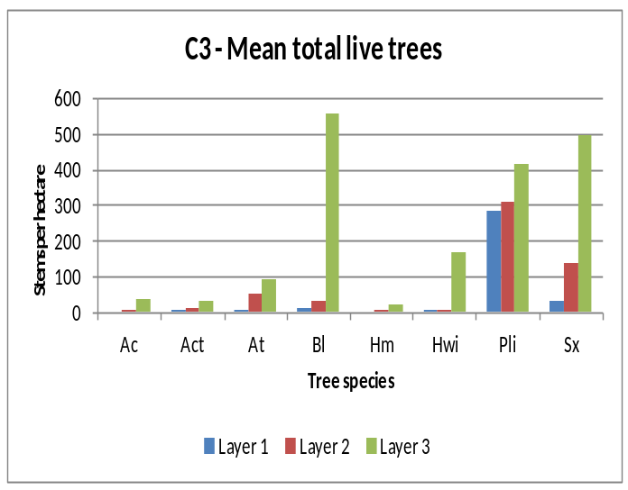
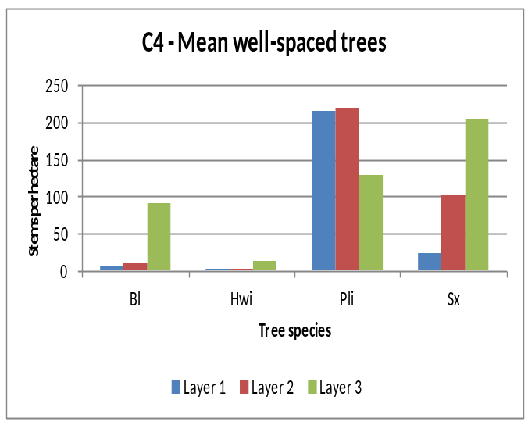

SPECIES COMPOSITION
Inventory labels are condensed representations of several stand attributes that describe conditions at the time of assessment. These attributes include leading, secondary and minor tree species by percentage class (usually rounded to the nearest 10%), average age and height of the dominant and co-dominant trees, a site index estimate, an estimate of crown closure, and the total trees per hectare. Inventory labels provide inputs used by the TASS stand model and by timber supply analysts projecting future stand development for timber supply purposes.

D1 - change in leading species between pre-sdm and sdm assessments
Leading Species at SDM | Leading Species Pre-SDM
Leading Species at SDM | ESSFmc |  |  |  |  |  |  | ICHmc1 |  |  |  |  |  | SBSdk |  |  |  |  |  |  |  | SBSmc |  |  |  |  |  | Allª
Leading Species at SDM |  |  | Bl | Pli | Sx |  |  |  |  | Bl | Pli | Sx |  |  |  |  | Bl | Pli | Sx |  |  |  |  | Bl | Pli | Sx |  |  |  |  | Bl | Pli | Sx
Bl |  |  | 0 | 1 |  |  |  |  |  | 0 |  |  |  |  |  |  | 0 |  |  |  |  |  |  | 1 |  |  |  |  |  |  | 1 | 1
Pli |  |  |  | 0 |  |  |  |  |  |  | 0 | 1 |  |  |  |  |  | 1 |  |  |  |  |  |  | 5 |  |  |  |  |  |  | 6 | 1
Sx |  |  |  |  | 0 |  |  |  |  |  |  | 0 |  |  |  |  |  |  | 0 |  |  |  |  |  |  | 0 |  |  |  |  |  |  | 0
Total |  |  |  | 1 |  |  |  |  |  |  |  | 1 |  |  |  |  |  | 1 |  |  |  |  |  | 1 | 5 |  |  |  |  |  | 1 | 7 | 1
(Shaded values indicate those polygons where the leading species has NOT changed). .
(In this TSA, no change in leading species was found in 7 (78%) of the 9 polygons sampled.)

D2 – tree species and layer used to calculate mean basal area
 | Number of Trees |  |  |  |  |  | Mean Polygon BA (m²/ha)
Tree spp. | Layer 1 |  | Layer 2 |  | All | Tree spp. | Layer 1 |  | Layer 2 |  | All
 | Live | Dead | Live | Dead |  |  | Live | Dead | Live | Dead
Bl | 4 |  | 13 | 1 | 18 | Bl | 0.18 |  | 0.21 | 0.01 | 0.40
Pli | 122 | 2 | 145 | 3 | 272 | Pli | 5.02 | 0.06 | 2.63 | 0.05 | 7.77
Sx | 14 |  | 58 |  | 72 | Sx | 0.57 |  | 0.89 |  | 1.46
Minor spp | 4 |  | 11 | 1 | 16 | Minor spp | 0.15 |  | 0.17 | 0.01 | 0.33
Total | 144 | 2 | 227 | 5 | 378 | Total | 5.93 | 0.06 | 3.90 | 0.07 | 9.96
% by layer | 38.1 | 0.5 | 73.3 | 1.3 |  | % by layer | 59.5 | 0.6 | 39.2 | 0.7
(Minor Spp. includes: Ac, Act, At, Cwi, Hm and Hwi.)

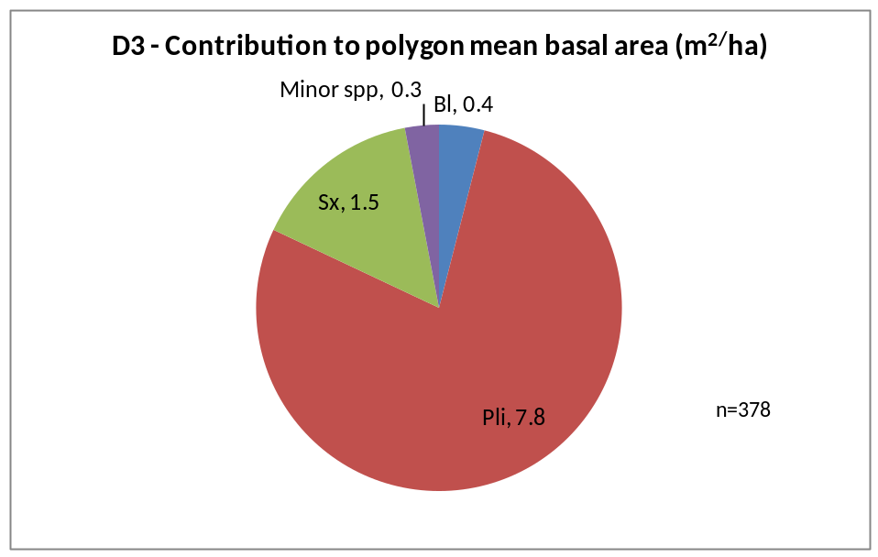

SITE INDEX
Site index was estimated using the growth intercept method. The estimates are the mean values of all available trees for that species in a BEC. Many stands do not have site index estimates recorded prior to the SDM survey.

E1 - mean site index estimate for dominant conifer species
 | Bl |  | Pli |  |  | Sx |  |  | Total
BEC | N | Mean | N | Mean | N |  | Mean | N
ESSFmc |  |  | 8 | 19.1 |  |  |  | 8
ICHmc1 |  |  | 2 | 21.5 | 7 |  | 21.6 | 9
SBSdk |  |  | 10 | 20.3 |  |  |  | 10
SBSmc2 | 2 | 8.7 | 46 | 19.2 | 4 |  | 16.2 | 52
ALL | 2 | 8.7 | 66 | 19.4 | 11 |  | 19.6 | 79

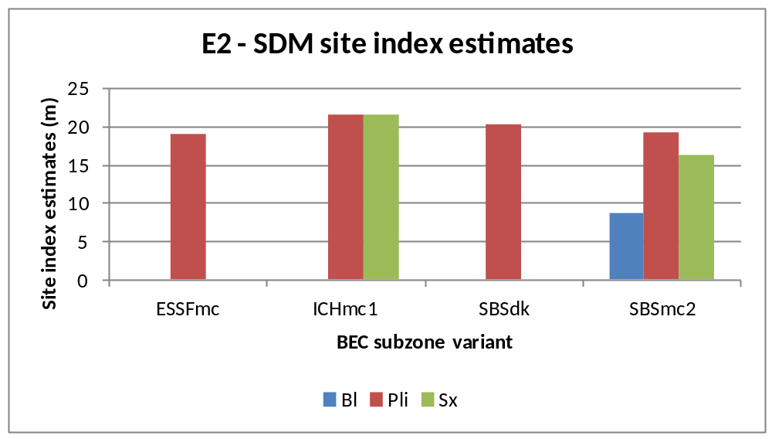

APPENDIX 1
BEC codes - http://www.for.gov.bc.ca/hre/becweb/index.html
Conifer pest codes - http://www.for.gov.bc.ca/hfp/health/fhdata/FS747%20conifer%2020111003.pdf
Conifer Tree Species codes http://www.for.gov.bc.ca/his/results/webhelp/index.htm
Deciduous pest codes - http://www.for.gov.bc.ca/hfp/health/fhdata/FS747%20deciduous%2020111003.pdf
SDM damage criteria - http://www.for.gov.bc.ca/hfp/silviculture/Surveys/SDM_Damage_Criteria_Feb_12_2010(2).pdf
SDM field cards - http://www.for.gov.bc.ca/ftp/HFP/external/!publish/FREP/indicators/FS%201357-SDMCard%20March%2012%2009.pdf
SDM survey protocol http://www.for.gov.bc.ca/ftp/HFP/external/!publish/FREP/Indicators/SDM%20Protocol%202011.pdf
Stocking Standards tables - http://www.for.gov.bc.ca/hfp/silviculture/stocking_stds.htm

APPENDIX 2
The complete list of openings, and polygons used in this report are listed here

TSA=Bulkley; Survey Year=2011 District=DSS
MAPSHEET | POLYGON | Year Logged (Smry) | BEC (Smry) | Polygon Net Area (Popn) | Leading Spp @ SDM (Smry) | Stand Age (Calc) | Total Live Trees @ SDM (Smry) | WS @ SDM (Smry) | SI @ SDM (Smry)
93L 055 122 | A | 1993 | ESSFmc | 43.2 | Pli | 18 | 4060 | 1260 | 19.9
93L 056 102 | 733 | . | SBSdk | 27.6 | Pli | . | 2420 | 900 | .
93L 072 022 | A | 1995 | SBSmc2 | 17.1 | Pli | 16 | 2660 | 1200 | 18.2
93L 093 039 | 914 | . | ICHmc1 | 9.9 | Sx | . | 3060 | . | .
93M 007 119 | 1041 | . | SBSmc2 | 11.6 | Pli | . | 1540 | . | 22.0
93M 017 015 | A | . | SBSmc2 | 22.9 | Pli | . | . | . | .
93M 017 016 | 465 | 1984 | SBSmc2 | 19.8 | Pli | 27 | 1860 | 900 | 18.4
93M 047 029 | 11 | 1995 | SBSmc2 | 10.3 | Bl | 16 | 4600 | 1080 | 18.7
93M 067 019 | B | . | SBSmc2 | 35.4 | Pli | . | 1600 | . | .

